INDUSTRIAL INTERNSHIP PROJECT ON

**AUTOMATIC STREET LIGHT SYSTEM**

PREPARED BY

KOLLU VAMSI



EXECUTIVE SUMMARY:

This report provides the details of the industrial internship provided by the upskill campus and the IOT academy in collaboration with industrial partner Unicoverage Technologies Pvt ltd (UCT).

The internship was focused on a AUTOMATIC STREET LIGHT SYSTEM provided by UCT. We had to finish the project including the report in 6 weeks' time.

My project was AUTOMATIC STREET LIGHT SYSTEM. In this project Arduino is used to control the streetlights (Turn on and off based on the light). Here we make use of LDR (Light Dependent Resistor) and LED (Light Emitting diode) and Arduino. You have seen the lights on the street which help in improving the clarity on roads at night. Also, nowadays we can see many fancy or decorative lights on streets, highways or on bridges too that gives a perfect view of modern cities.

This internship gave me a particularly good opportunity to get exposure to industrial problems and design\implement solution for that. It was an overall wonderful experience to have this internship.

**Table of contents**

* Preface
* Introduction
* Problem statement
* Existing and proposed solution
* Proposed design and model
* Performance test
* My learnings
* Future scope

**PREFACE**

* **I had learnt about the IOT technologies in the 6 week internship program. I had also attempted the 3 quizzes related to the IOT embedded systems.**
* **I had got an good opportunity to do internship with UNICOVERAGE TECHNOLOGIES.**
* **As the future is going to be automated this IOT plays major role where it is used in every aspect of day to day life.so I am very happy to take relevant internship for carrer development.**
* **I had done a project called automatic street light system where an arduino,LDR,LED are used whenever light falls this streetlight gets turned on automatically and when light comes it switches off automatically due to use of LDR. It is mainly dependent on the resistance of LDR.**
* **I had learnt many things while doing internship. I had got confidence by watching videos given in internship now I am able to attend any interview in this internship they had said many tips to crack the interview.**
* **My special thanks to UCT and upskill campus who helped me to do internship in this company. I am so happy and I told many of my friends to take internship in upskill campus.**
* **My message to juniors and peers to follow the instructions of upskill campus and UCT to get succeeded in the life.**

**INTRODUCTION**

About Unicoverage Technologies Pvt Ltd

Uniconverge Technologies Private Limited is a Private incorporated on 28 May 2013. It is classified as Non-govt company and is registered at Registrar of Companies, Kanpur. Its authorized share capital is Rs. 100,000 and its paid up capital is Rs. 100,000. It is inolved in Data processing. [This includes the processing or tabulation of all types of data. Provision of such services on (i) an hourly or time -share basis, and (ii) management or operation of data processing facilities of others on a time sharing basis; on a fee or contract basis].  
  
Uniconverge Technologies Private Limited's Annual General Meeting (AGM) was last held on 30 November 2021 and as per records from Ministry of Corporate Affairs (MCA), its balance sheet was last filed on 31 March 2021.  
Directors of Uniconverge Technologies Private Limited are Archana Sisodia, Kaushlendra Singh Sisodia.

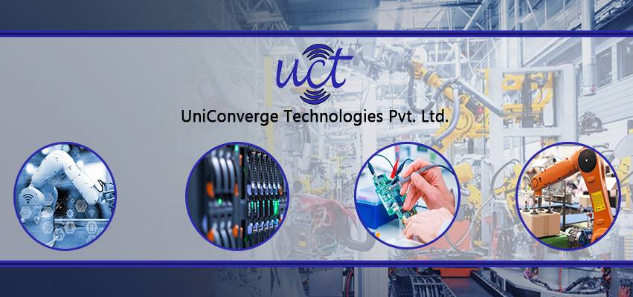

**UCT IOT PLATFORM**

UCT INSIGHT is an IOT platform designed for quick deployment of IOT applications on the same time providing valuable “insight” for your process\business. It has been built in java for bacend and Reactus for front end. It has support for MYSQL and various NOSQL databases.

Features of insight are

* Build your own dashboard
* Analytics and reporting
* Alert and notification

**LORAWAN**

Unicoverage is one of the early adopter of LoraWAN technology and providing solution in Agritech, Smart cities,smart street light,smart water,etc..

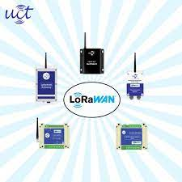

**ABOUT UPSKILL CAMPUS**

* Upskill Campus is a fast-growing ed-tech platform that is meant to upskill students, freshers, working professionals, faculties, entrepreneurs etc.
* A carrer development platform that delivers personalized executive coaching in a more affordable, scalable and measurable way.



**The IOT academy**

The iot academy is Edtech division of UCT that is running long executive certification programs in collaboration with EICT academy,IITK,IITR and IITG in multiple domains.

**Objectives of this internship**

* To get practical experience of working in the industry.
* To solve real world problems.
* To have improved job prospects.

**References**

* LinkedIn
* YouTube
* Google

**PROBLEM STATEMENT**

**AUTOMATIC STREET LIGHT SYSTEM**

In this project I used Arduino, LDR, LED to switch on switch off the lights automatically depending on light.

**EXISTING AND PROPOSED SOLUTION**

* In past the street lights were operated by the people so when ever sunsets a worker need to turn all the street lights and again the morning he needs to go switch off them. So it is very difficult to operate the entire society. So by using this automatic street light system no worker is required to turn on and off the light also it saves the money to government and also power will be saved a lot by using this system.Depending upon the threshold value of LDR which we were given the system will be operated.
* There are lower chances of the automatic street light system overheating & risk of accidents is also minimized. Cost of operating automatic solar street lights is far less when compared to the conventional street lights. The automatic street light system is eco-friendly & hence helps in reducing the carbon footprint.

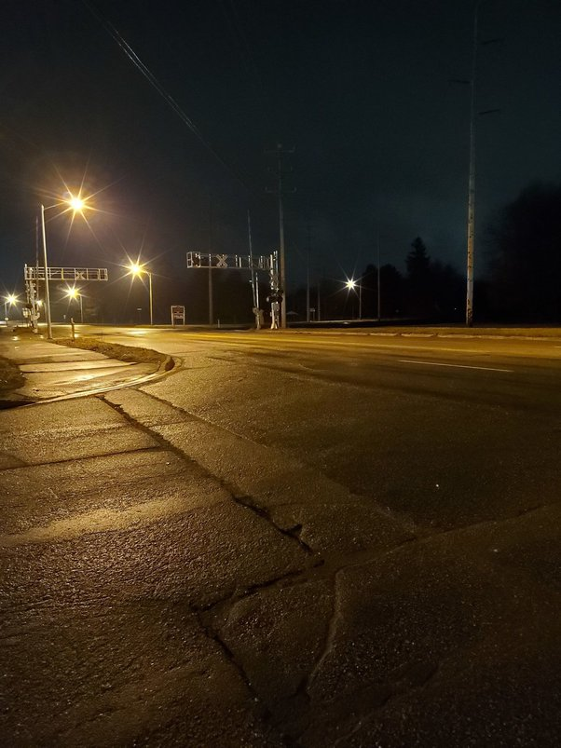

**PROPOSED DESIGN AND MODEL**

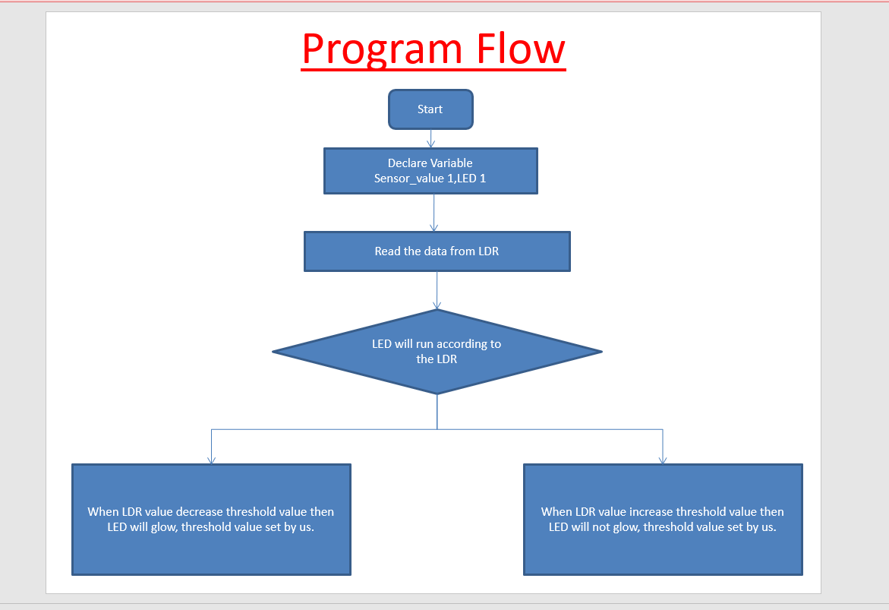

**LOW LEVEL DIAGRAM**

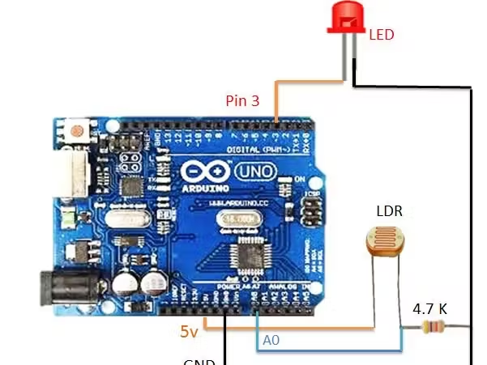

**PROTOCOL OF SYSTEM**

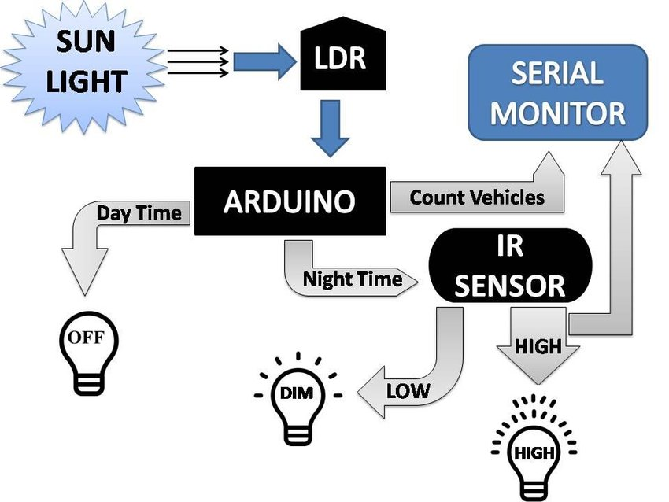

**PERFORMANCE TEST**

This is the circuit done in the proteus software by using various components.

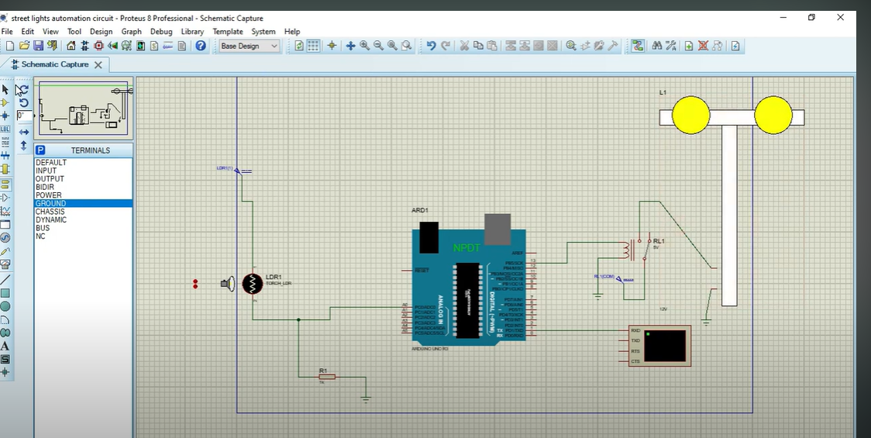

**CODE FOR ARDUINO UNO R3**

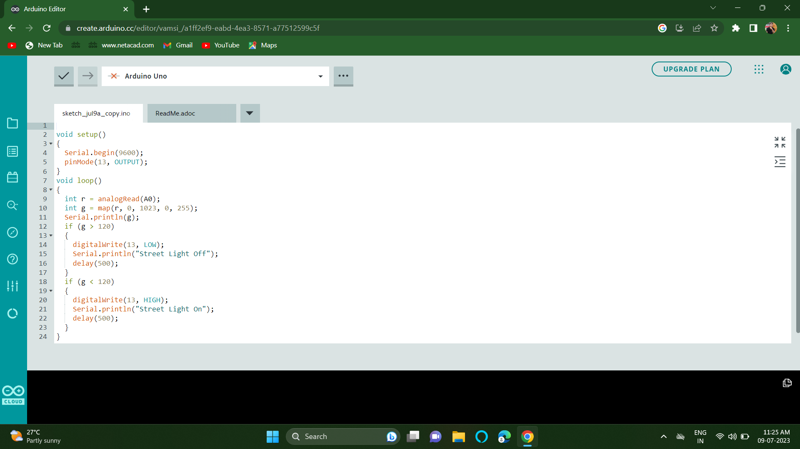

**Test cases**

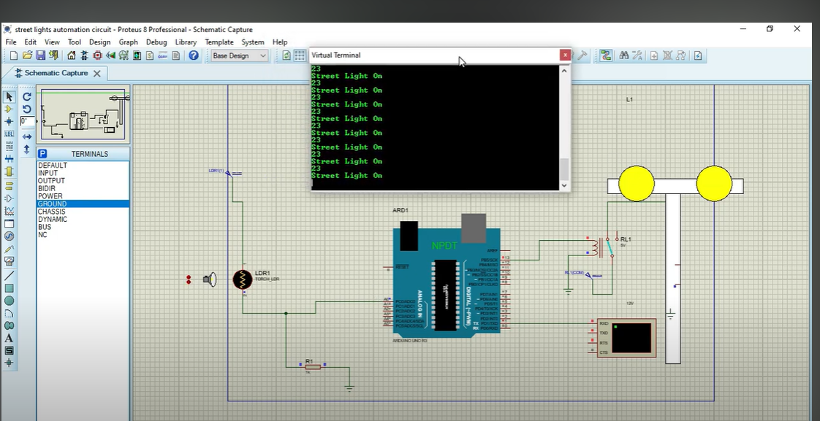

STREETLIGHT TURNS ON

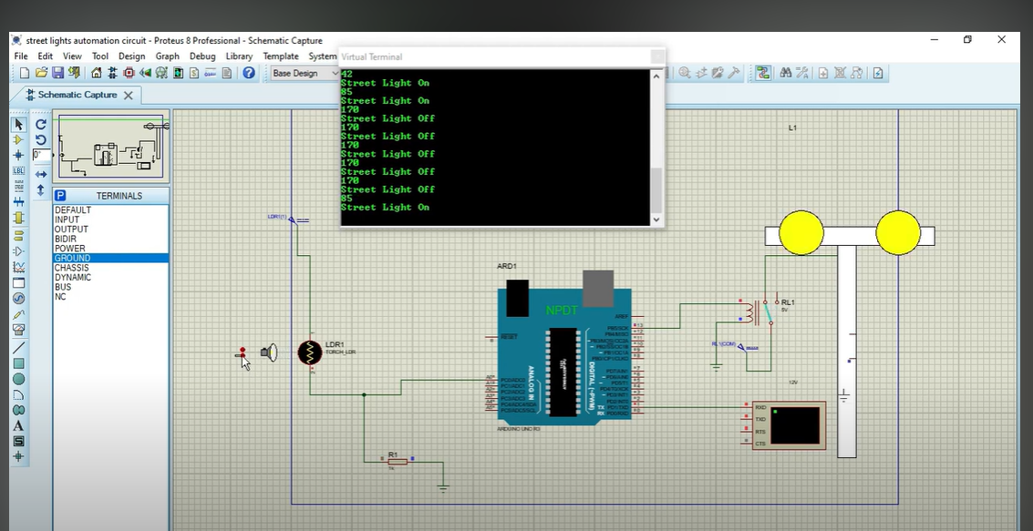

STREETLIGHT TURNS OFF

**MY LEARNINGS**

From this project I learnt about the Arduino uno and how to do the project and how to use this software and I am so happy to complete this project. With this project accidents will be reduced during the night-time and the main thing is energy will be saved.

**FUTURE WORK SCOPE**

* At present we designed a circuit where the streetlights will be turned on whenever the light fails. In future we can develop this by making These smart lights will help cities reduce electricity costs, lower CO2 emissions, and improve maintenance. With auto-dimming, scheduling, and a host of other capabilities, cities could see a 50-75% reduction in energy costs via smart street lighting.
* Analysts predict that as much as 89% of the planet's 363 million streetlights will have adopted LED technology by 2027. It makes financial sense. The switch to LED represents an effective reduction in costs, maintenance and environmental degradation.
* This project of AUTOMATIC STREET LIGHTS is a cost effective, practical, ecofriendly and the safest way to save energy. It clearly tackles the two problems that world is facing today, saving of energy and also disposal of incandescent lamps, very efficiently.